**Cyclistic Bike-Share Case Study Report**

**1. Business Task**

Cyclistic, a bike-share program based in Chicago, has experienced strong growth but now seeks to convert more casual riders into annual members to increase long-term profitability. As a junior data analyst, my goal was to explore how annual members and casual riders use Cyclistic bikes differently, using insights from historical trip data. These findings will inform targeted marketing strategies to drive membership growth.

**Key Question:**

* How do annual members and casual riders use Cyclistic bikes differently?

**2. Data Sources**

**Data Origin:**

* Cyclistic (Divvy) trip data provided publicly by Motivate International Inc.
* URL: <https://divvy-tripdata.s3.amazonaws.com/index.html>

**Data Overview:**

* 12 individual monthly CSV files covering one year of trip-level data.
* Key fields: rider type (member_casual), start/end times, rideable type, start/end stations.

**Tools Used:**

* **Google Big Query** for SQL-based data cleaning and analysis.
* **Tableau Public** for data visualization.
* **Google Sheets** was initially tested but deemed too limited for the dataset size.

**Data Cleaning Steps:**

* Combined all monthly CSVs into one dataset.
* Removed nulls and rides with negative or extremely long durations (>24 hrs).
* Created new calculated fields:
  + ride_length in minutes (ended_at - started_at)
  + day_of_week derived from start timestamp.

**3. Key Findings**

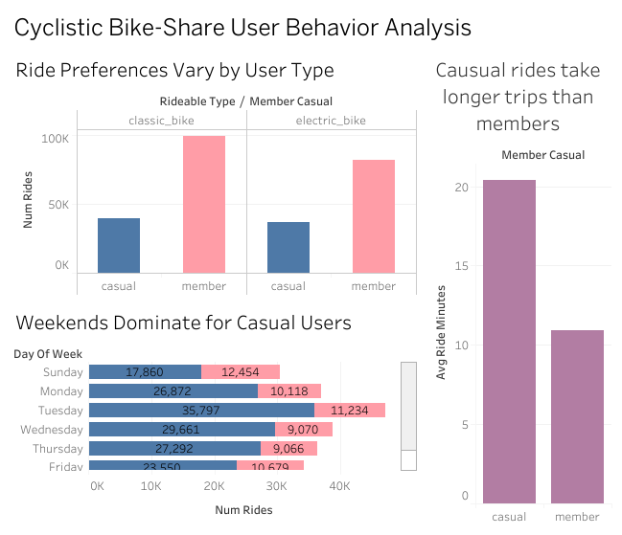

**A. Ride Duration**

* Casual riders take significantly longer trips:
  + Casual: ~33–35 minutes
  + Members: ~12–15 minutes
* Suggests that casual riders are more leisure-oriented.

**B. Day of Week Usage**

* Casual usage spikes on weekends (Saturday & Sunday).
* Members show consistent weekday usage, peaking on Mondays to Fridays.
* Indicates members are more likely commuting to work.

**C. Rideable Type Preferences**

* Casual riders prefer classic bikes.
* Members show higher usage of electric and docked bikes.
* Reflects members’ need for convenience and efficiency.

**4. Recommendations for Cyclistic Marketing Team**

**1. Launch a “Weekend to Weekday” Promotion**

* Target casual riders who frequently ride on weekends.
* Offer a free weekday ride to encourage commute-based use.
* Goal: Increase awareness of weekday utility and convert to memberships.

**2. Personalized Ride Summary Emails**

* Use backend analytics to email casual users with personalized reports showing:
  + Number of rides
  + Total minutes ridden
  + Estimated cost savings if they were members
* Goal: Show clear financial benefits of switching.

**3. Highlight Member-Exclusive Perks**

* Promote electric and docked bike access as member-only benefits.
* Emphasize faster, more convenient rides in marketing materials.
* Goal: Create value perception and incentivize sign-ups.

**5. Conclusion**

Through SQL-based analysis of Cyclistic trip data and visual storytelling in Tableau Public, we identified key behavioral differences between casual riders and members. These insights support a focused marketing strategy aimed at converting casual users into annual members by highlighting commute benefits, cost savings, and exclusive features.

This project demonstrates how data-driven storytelling can support strategic decision-making in a real-world business context.